Download a sample IAM policy JSON
Tasks
1.
Download a sample IAM policy JSON (for example, from AWS documentation), identify all users and their permissions, and list any permissions that are broader than necessary for typical user actions.
2.
Edit the given IAM policy to implement least privilege access for a food delivery app scenario (e.g., only allow delivery agents to update order status, not delete orders), and save your revised policy as optimized_policy.json.
3.
Review an IAM policy that grants full S3 access to a group called 'AppUsers' and modify it so users can only read from a specific bucket named 'user-uploads', not write or delete files.<br><br><em><strong>Hint:</strong> Use the 'Action' and 'Resource' fields to restrict permissions.</em>
4.
Write a checklist of 5 steps you would follow to regularly review IAM policies for a movie ticket booking app (like BookMyShow), including how you would identify unused permissions and revoke them.
5.
Use ChatGPT or another AI tool to analyze a provided IAM policy snippet and suggest at least two improvements to enhance security following best practices.<br><br><em><strong>Hint:</strong> Paste the policy into the AI tool and ask for recommendations based on least privilege and regular review.</em>

Answer : Task 1: Download a Sample IAM Policy and Analyze It

Step 1: Get a sample IAM policy
Go to the AWS IAM documentation and copy a sample policy.
Example policy:
{
"Version": "2012-10-17",
"Statement": [
{
"Effect": "Allow",
"Action": [
"s3:*"
],
"Resource": "*"
}
]
}

Step 2: Identify users
Users: None are mentioned in this policy.
IAM policies do not contain user names. They are attached to users, groups, or roles in AWS.

Step 3: Identify permissions
Permission given:
- s3:* → Full access to Amazon S3
  - Read files
  - Upload files
  - Delete files
  - Create buckets
  - Delete buckets
  - Manage permissions

Step 4: Find permissions that are too broad
Permission | Why it's too broad
s3:* | Gives complete control over S3. Most users only need read or upload access.
"Resource": "*" | Gives access to every S3 bucket instead of one specific bucket.
Little Info:
- Least Privilege means users should only get the permissions they actually need.

Task 2: Optimize IAM Policy for a Food Delivery App

Scenario
Delivery agents should:
- ✅ View orders
- ✅ Update order status
- ❌ Delete orders
- ❌ Create orders

Original Policy (Too Much Access)
{
"Version": "2012-10-17",
"Statement": [
{
"Effect": "Allow",
"Action": "orders:*",
"Resource": "*"
}
]
}

Optimized Policy (Save as optimized_policy.json)
{
"Version": "2012-10-17",
"Statement": [
{
"Effect": "Allow",
"Action": [
"orders:GetOrder",
"orders:UpdateOrderStatus"
],
"Resource": "*"
}
]
}

Save
- Open Notepad or VS Code.
- Paste the JSON.
- Click File → Save As.
- Name it:
optimized_policy.json
Little Info:
- Only necessary actions are allowed.
- Delete permission is removed.

Task 3: Restrict S3 Access
Original Policy
{
"Version": "2012-10-17",
"Statement": [
{
"Effect": "Allow",
"Action": "s3:*",
"Resource": "*"
}
]
}

Required
Group: AppUsers
Only:
- Read files
- Bucket name: user-uploads
No upload.
No delete.

Modified Policy
{
"Version": "2012-10-17",
"Statement": [
{
"Effect": "Allow",
"Action": [
"s3:GetObject",
"s3:ListBucket"
],
"Resource": [
"arn:aws:s3:::user-uploads",
"arn:aws:s3:::user-uploads/*"
]
}
]
}

Explanation
Action | Meaning
s3:GetObject | Read/download files
s3:ListBucket | View bucket contents
No PutObject | Cannot upload
No DeleteObject | Cannot delete
Little Info:
- Action defines what users can do.
- Resource defines where they can do it.

Task 4: IAM Review Checklist (Movie Ticket Booking App)
IAM Policy Review Checklist
✅ 1. Review User Roles
- Check whether employees still need their current access.

✅ 2. Find Unused Permissions
- Use AWS IAM Access Analyzer or CloudTrail to identify permissions that are never used.

✅ 3. Remove Extra Permissions
- Revoke permissions that users no longer require.

✅ 4. Verify Least Privilege
- Ensure users have only the permissions needed for their job.
- Example:
  - Customer Support → View bookings only.
  - Admin → Manage movies and users.

✅ 5. Schedule Regular Reviews
- Review IAM policies every 3–6 months or after role changes.
Little Info:
Regular reviews reduce security risks and help prevent unnecessary access.

Task 5: AI Analysis of an IAM Policy
Sample Policy
{
"Version": "2012-10-17",
"Statement": [
{
"Effect": "Allow",
"Action": "s3:*",
"Resource": "*"
}
]
}

Prompt for ChatGPT
Analyze this IAM policy and suggest improvements based on AWS least privilege best practices.

AI Suggestions
Improvement 1
Replace
"s3:*"
with
"s3:GetObject"
or only the specific actions required.
Reason:
Avoid giving full S3 access.

Improvement 2
Replace
"Resource": "*"
with
"arn:aws:s3:::user-uploads/*"
Reason:
Restrict access to only the required S3 bucket.

Bonus Improvement
Use separate IAM roles for different users.
Example:
- Admin → Full access
- Delivery Agent → Update order status only
- Customer Support → Read orders only
This follows the principle of least privilege.

Quick Revision
Task | What You Did
1 | Analyzed an IAM policy and identified overly broad permissions (s3:*, Resource: "*")
2 | Created optimized_policy.json with only the required order permissions for delivery agents
3 | Restricted S3 access so AppUsers can only read from the user-uploads bucket
4 | Wrote a 5-step IAM policy review checklist for a movie ticket booking app
5 | Used AI-style analysis to recommend limiting actions and resources according to least-privilege best practices
These examples are suitable for learning IAM concepts and completing a typical AWS security lab or assignment.

Example 1: IAM Policy (Before vs After)
Before (Too Much Access)
{
"Version": "2012-10-17",
"Statement": [
{
"Effect": "Allow",
"Action": "s3:*",
"Resource": "*"
}
]
}
Problem
- User can read files ✅
- Upload files ✅
- Delete files ✅
- Create buckets ✅
- Manage all S3 buckets ✅
This is not following the Least Privilege Principle because it gives full access. (Amazon Web Services, Inc.)

After (Least Privilege)
{
"Version": "2012-10-17",
"Statement": [
{
"Effect": "Allow",
"Action": [
"s3:GetObject",
"s3:ListBucket"
],
"Resource": [
"arn:aws:s3:::user-uploads",
"arn:aws:s3:::user-uploads/*"
]
}
]
}
Now the user can:
- ✅ View bucket
- ✅ Read files
- ❌ Upload files
- ❌ Delete files
This follows the least privilege principle by allowing only the required actions on a specific bucket. (Repost)

Example 2: Food Delivery App
Delivery Agent Permissions
Action | Allow?
View Orders | ✅ Yes
Update Order Status | ✅ Yes
Delete Orders | ❌ No
Cancel Orders | ❌ No
Manage Users | ❌ No
Example policy:
{
"Version": "2012-10-17",
"Statement": [
{
"Effect": "Allow",
"Action": [
"orders:GetOrder",
"orders:UpdateOrderStatus"
],
"Resource": "*"
}
]
}

Example 3: Movie Ticket Booking App
Different IAM Roles
User | Permissions
Customer | Book tickets
Customer Support | View bookings
Admin | Manage movies and users
Payment Service | Process payments
This is another example of least privilege because each role receives only the permissions needed for its job.

Example Images
1. IAM User and Policy
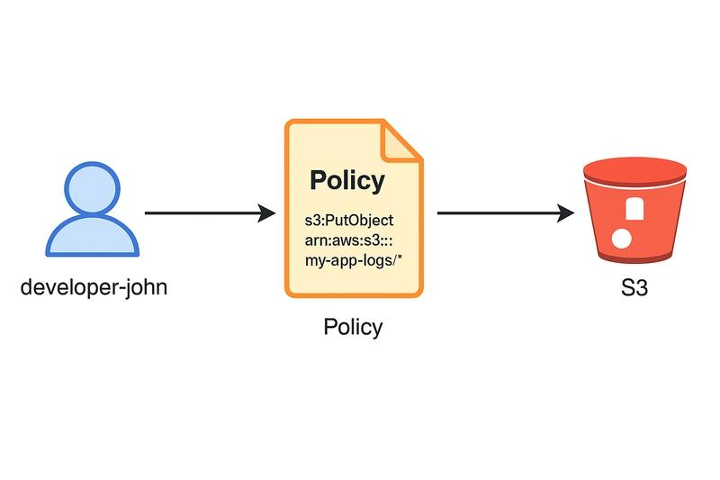
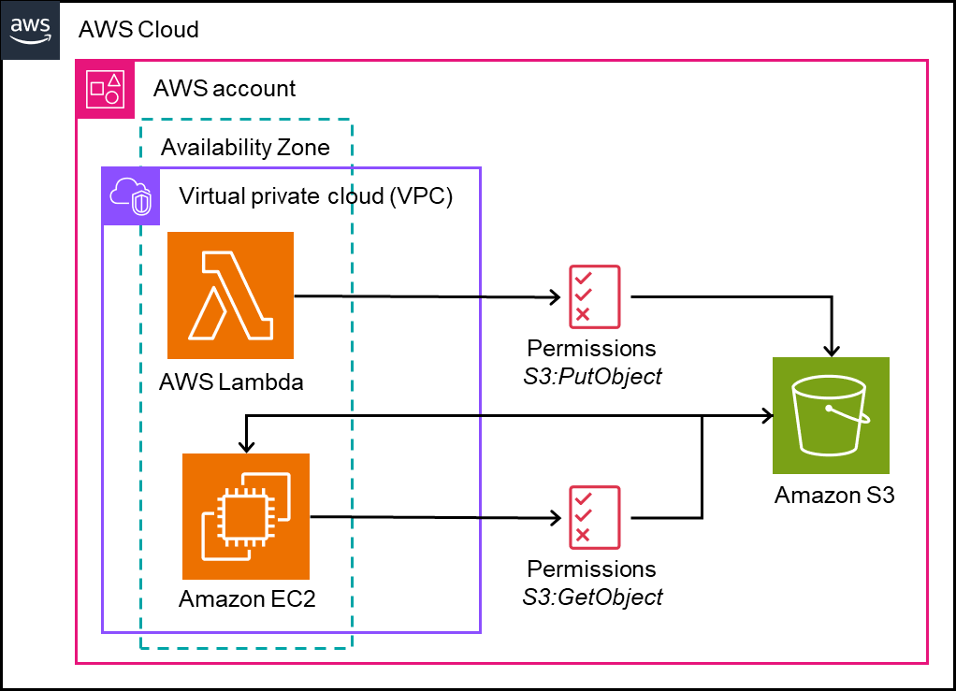
Explanation:
- An IAM User is assigned an IAM Policy.
- The policy determines what actions (such as s3:GetObject or s3:PutObject) the user is allowed to perform.

2. S3 Bucket Policy Example
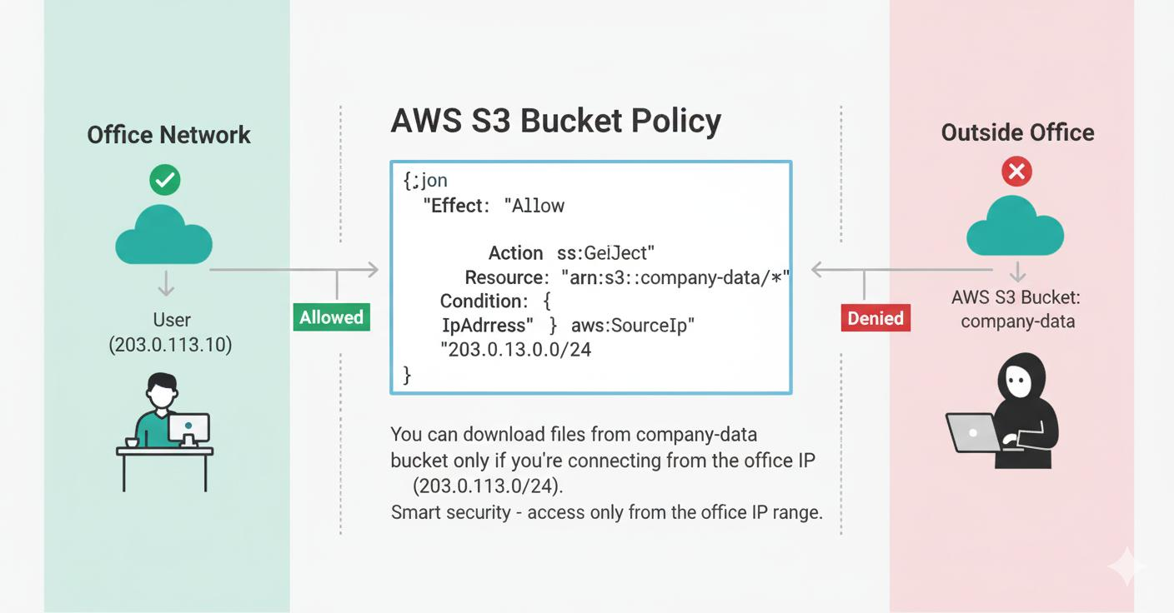
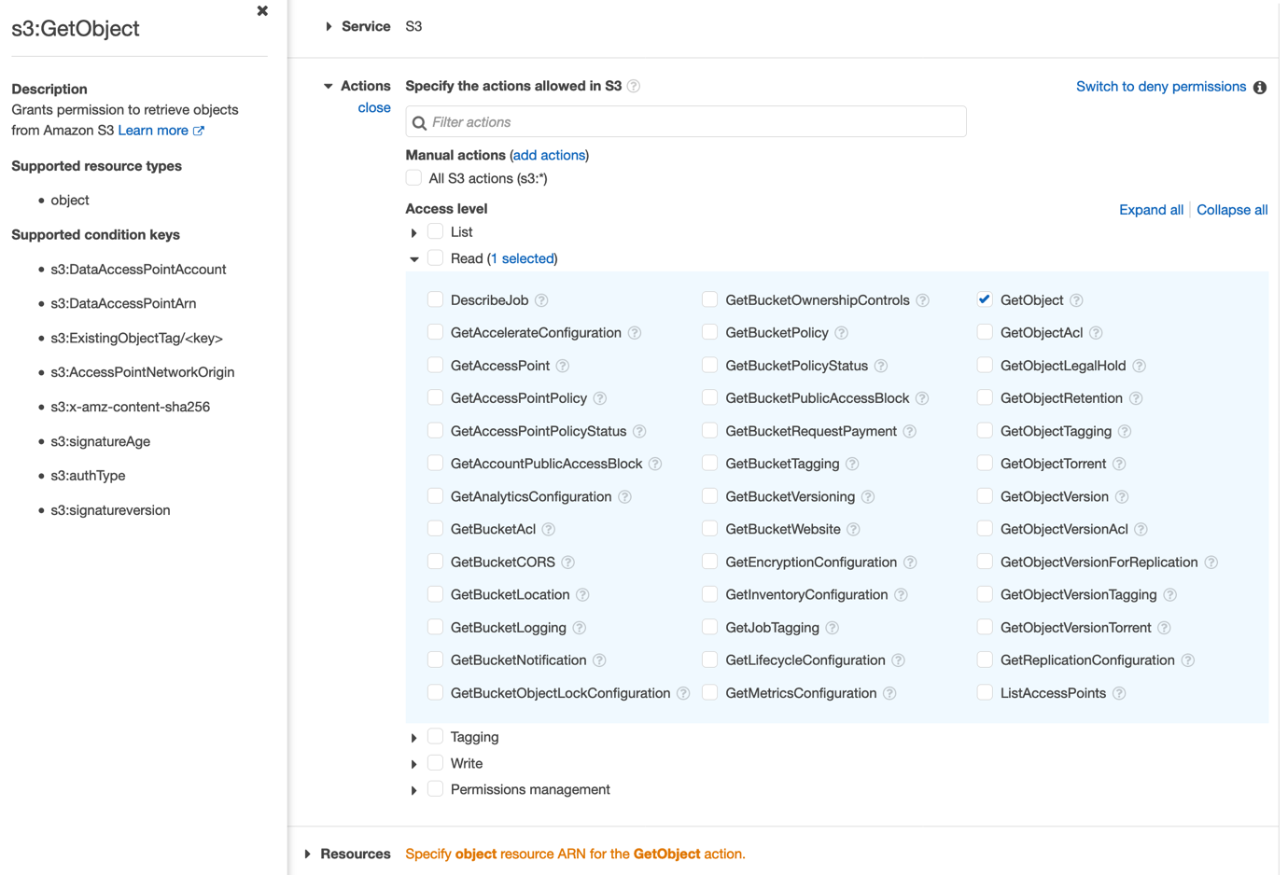
Explanation:
- Policies can allow access only to a specific S3 bucket.
- They can also limit access by action (read-only) or add conditions such as source IP addresses for stronger security. (Amazon Web Services, Inc.)

Easy Diagram for Your Assignment
IAM User
│
│
IAM Policy
│
┌───────┴────────┐
│ │
Allow Read Deny Delete
│ │
▼ ✖
S3 Bucket Cannot Delete Files

Real-Life Example
Imagine a food delivery app:
👨‍🍳 Restaurant
- Add menu
- Update menu
🛵 Delivery Agent
- View assigned orders
- Update delivery status
- Cannot delete orders
👤 Customer
- View order history
- Place orders
- Cannot manage restaurants
Each person gets only the permissions needed to do their job, which is the principle of least privilege.

Short Viva/Interview Answer
What is IAM?
IAM (Identity and Access Management) is an AWS service used to securely manage users, groups, roles, and permissions. It controls who can access AWS resources and what actions they are allowed to perform.
What is Least Privilege?
Least privilege is the security principle of granting users only the minimum permissions they need to perform their tasks, reducing the risk of accidental or unauthorized actions.

